**Lambda Functions in Python**

**What is a Lambda Function?**

* A **tiny, anonymous function** created using the lambda keyword.
* Unlike regular functions (def), **lambdas are used for short, one-time operations**.
* They do **not need a name**, making them quick and efficient

Here are the **proper syntax** and **examples** for **Lambda functions in Python**

**1. Lambda vs Regular Function (Squaring a Number)**

**Syntax**

lambda x: x * x

* lambda – Keyword to define the function.
* x – Input argument.
* x * x – Expression that calculates the square of x.

**Example**

**Regular function**

def square(x):

return x * x

**Equivalent lambda function**

square_lambda = lambda x: x * x

print(square_lambda(4)) # Output: 16

✅ **Lambda saves space** by performing the same task in one line.

**2. Lambda Function with Multiple Inputs (Adding Two Numbers)**

**Syntax**

lambda x, y: x + y

* x, y – Input arguments.
* x + y – Expression that adds both numbers.

**Example**

# Regular function

def add(x, y):

return x + y

# Equivalent lambda function

add_lambda = lambda x, y: x + y

print(add_lambda(3, 5)) # Output: 8

✅ **Short & direct** compared to defining a full function.

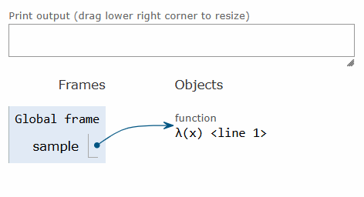

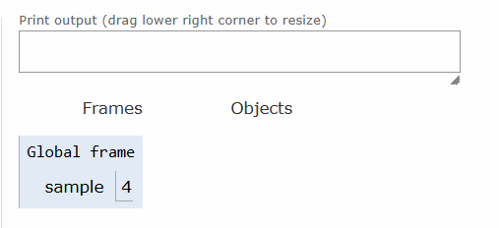

1.if we assign a function expression as a value/object to any variable

2.if we pass a function expression as an argument to the other function

3.if a function returns another function

4.if u add a function as a list element

Then function can be said to be as a first-class function

1.function without parameters

2.with parameters(with positional arguments)

3.with default parameters

4.arbitrary arguments (*args)

5.keyword arguments

6.arbitrarykeywordargs(**kwargs)

7.lambda functions

8.defintion if firstclass functions

9.recursive function

RAMCHARAN-🡪INCASE IF WE KNOW HIM IN TOLLOWOOD,KOLLYWOOD,BOLLYWOOD

GLOBAL STAR-🡪HE IS HAVING SCOPE IN GLOBAL CINEMA

MEGAPOWERSTAR-🡪HE IS HAVING ONLY SCOPE IN TOLLYWOOD CINEMA

HE IS HAVING DUAL SCOPE-🡪ENCLOSING SCOPE

SCOPES-🡪GLOBAL,LOCAL AND ENCLOSED SCOPE,built-in scope